SPORTS DAY REGISTRATION

Linux Shell Scripting Project Report
Project: L81 – Sports Day Registration
Student: PATEL VED VIPULKUMAR
Roll No.: D39 Division: H
Enrollment No.: 24004501210289
Environment: Ubuntu Linux / Bash Project Folder: ~/linux_project/sportsday

Introduction and Objectives
Sports Day Registration is a menu-based shell script for the sports committee. It lets the committee register students for events, stop duplicate entries, count players in each event, see the list of each house, print winner certificates and remove wrong entries. All data is kept in one CSV file called participants.csv.
Problem: Make a sports day registration system that stops duplicate entries and creates certificates. Users: sports committee members.

Objectives
- Make a menu-based Bash program using while and case.
- Register students and stop duplicate entries (grep).
- Count players in each event (sort and uniq -c).
- Show the list of students in one house.
- Create a certificate file for each winner (here-document in a for loop).
- Remove a registration safely (sed -i).
- Check user input, keep an activity log and make tar.gz backups.
- Back up participants.csv every day at 6 PM using crontab.

Data File: participants.csv
The file has one header line and 32 registrations. It has four columns:
Column | Meaning
roll | Student roll number: one letter and numbers (example: G01)
name | Student name in capital letters
house | House team: Red, Blue, Green or Yellow
event | 100m, 200m, Long Jump, High Jump, Shot Put, Relay, Chess or Carrom

One student can join many events (for example, G01 is in 100m and Long Jump). But the same roll cannot join the same event two times. This is the duplicate check.

Project Folder Structure
sportsday/
├── main.sh
├── README.md
├── lib/
│ └── functions.sh
├── data/
│ └── participants.csv
├── reports/
│ └── certificates/
├── backups/
└── logs/
└── activity.log

main.sh shows the main menu. functions.sh has all the feature functions. The data folder keeps participants.csv. The reports folder keeps certificates and cron output. The backups folder keeps backup files and the logs folder keeps the activity log.
Screenshot: Running the setup script
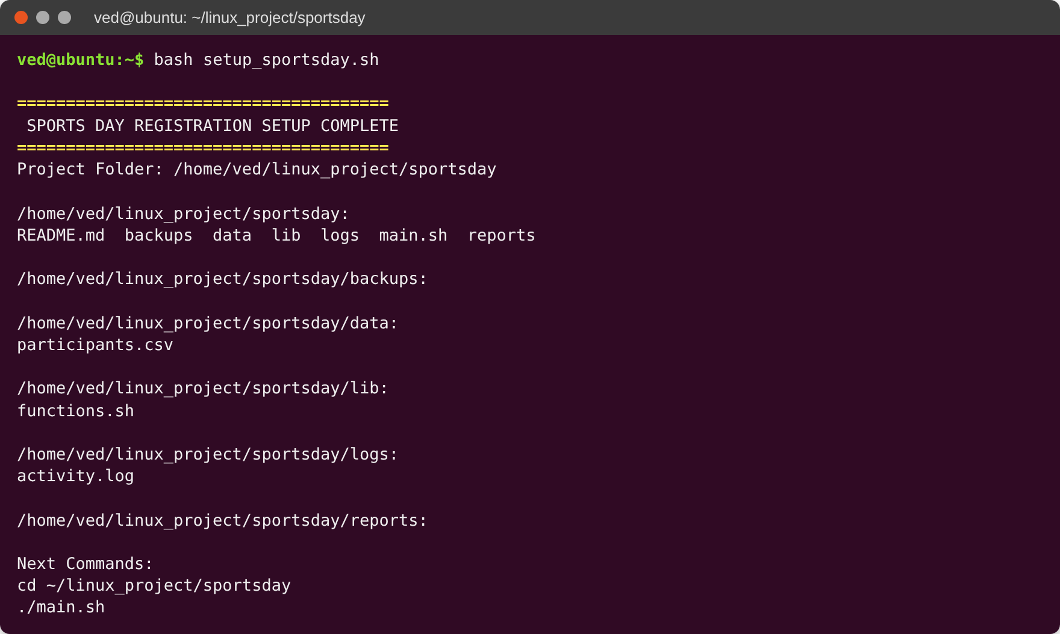
Screenshot: Project files and number of rows in the data file
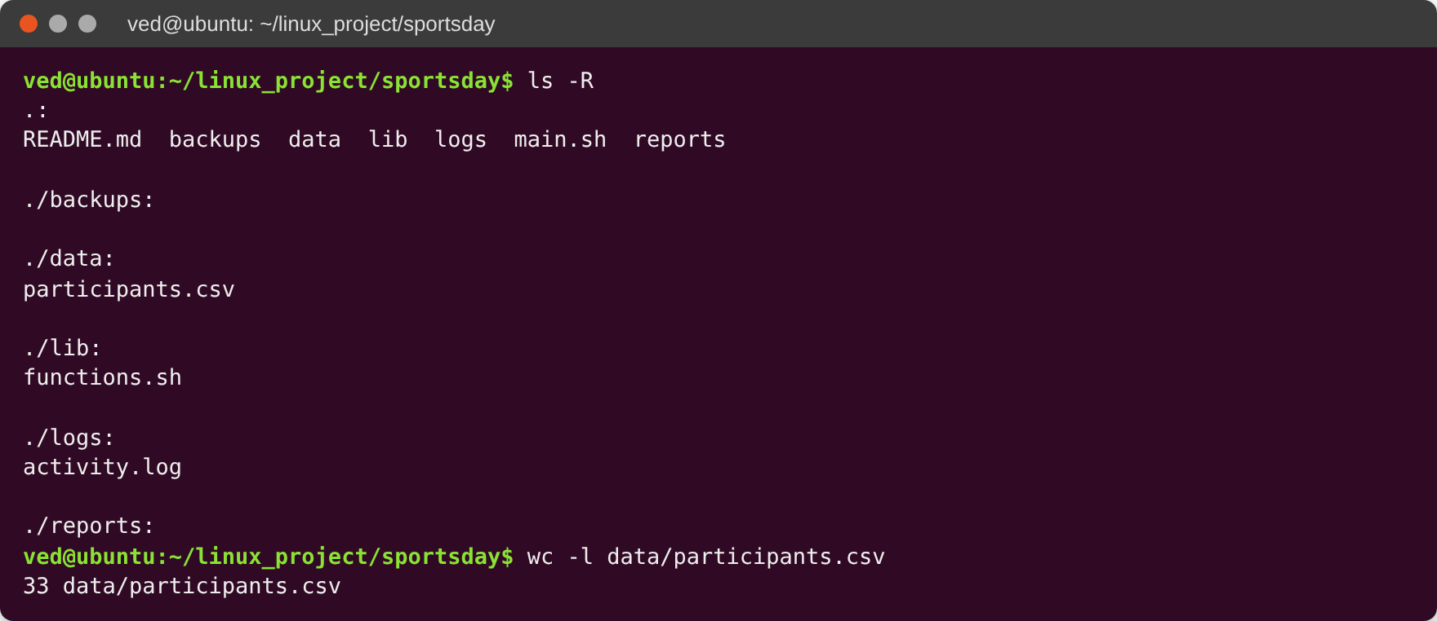
Screenshot: Main menu
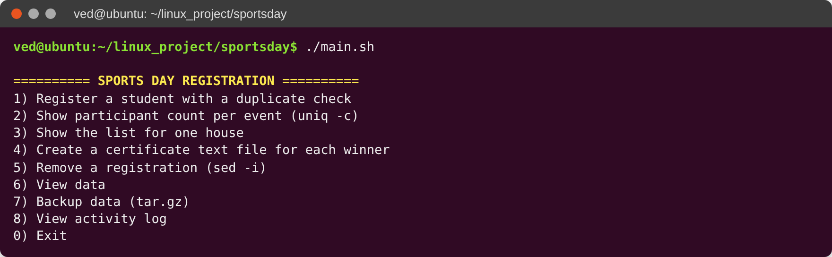

Feature 1: Register a Student (Duplicate Check)
The user enters the roll number and name. Then the user picks a house (for new students) and an event from a numbered list. Before saving, the script uses grep to look for the same roll with the same event. If it finds one, the entry is rejected and written in the log. If not, the new row is added to participants.csv with >>.
Input checks: empty values, commas, wrong roll format (like 31X), a roll that already has a different name, and wrong house or event numbers are all rejected.
Screenshot: Feature 1 – Registering a new student (G31)
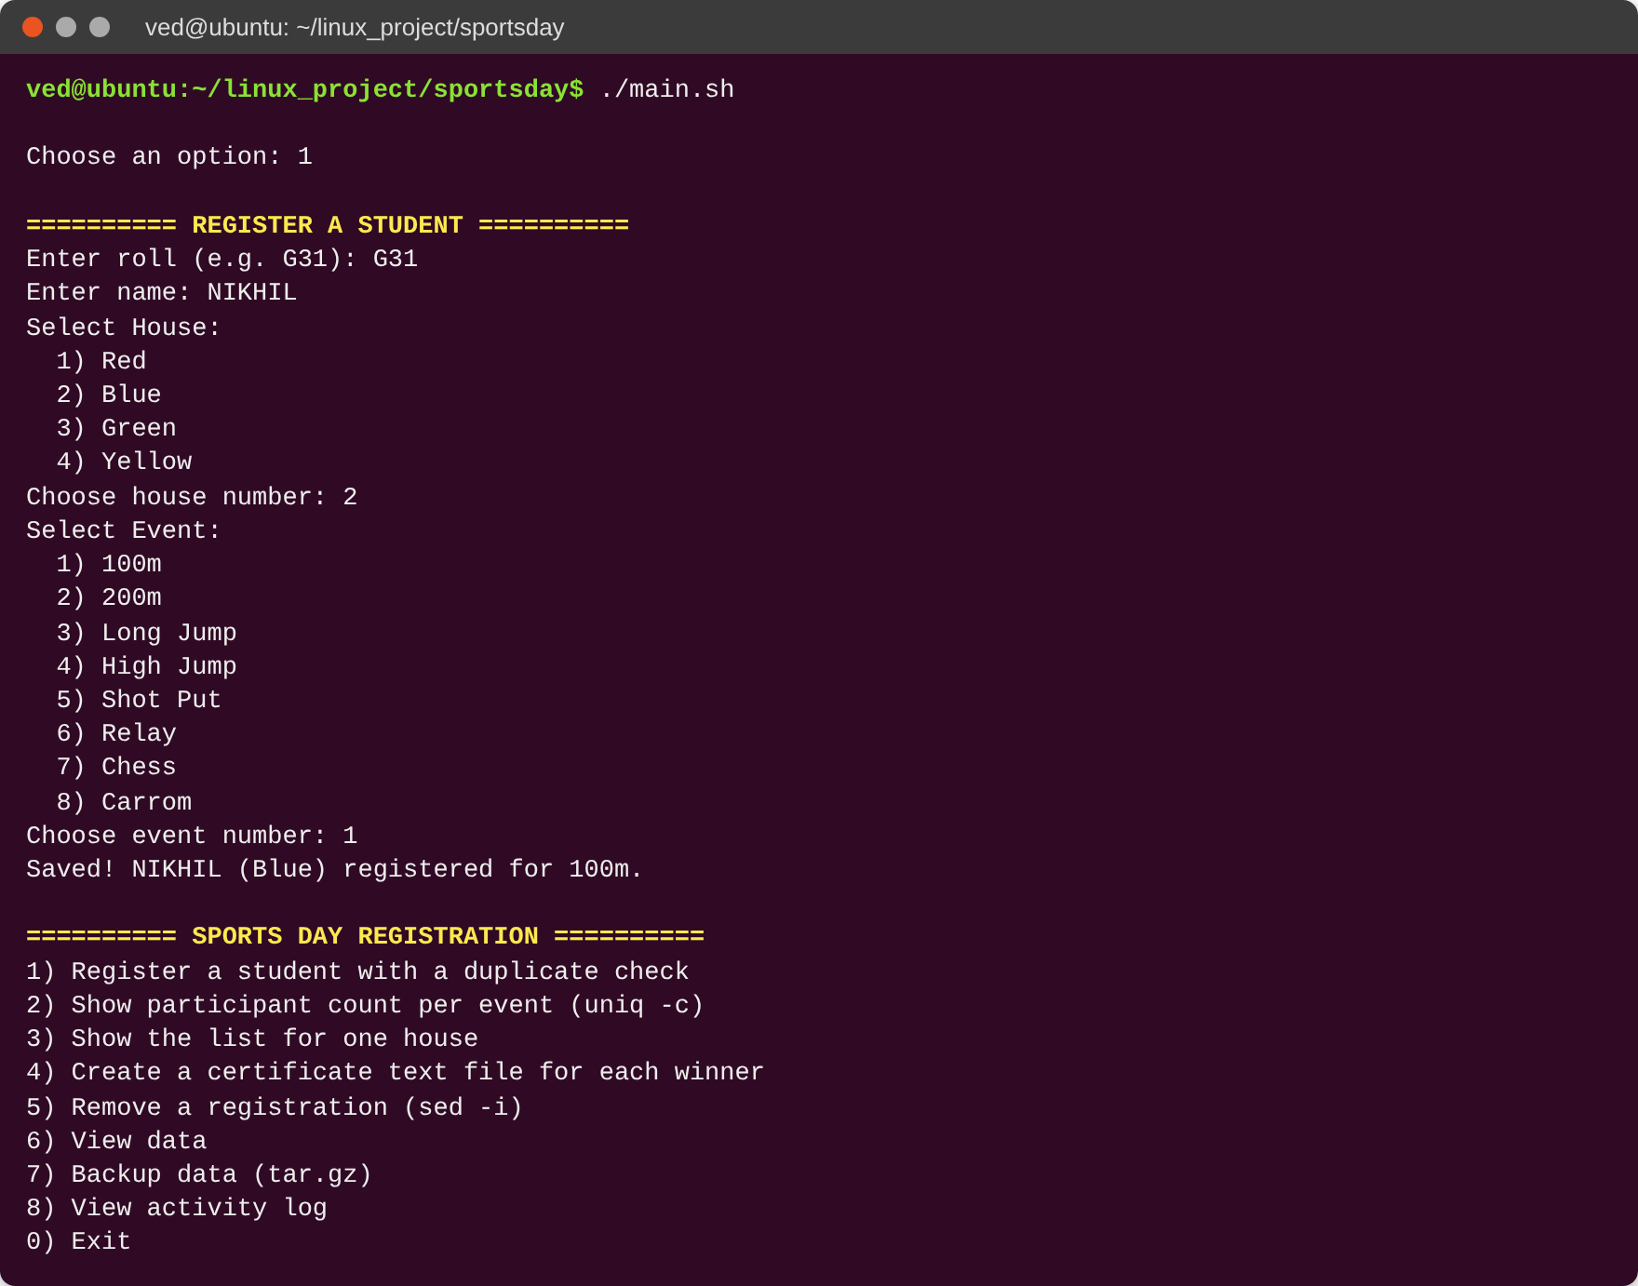
Screenshot: Feature 1 – Duplicate entry and wrong input rejected
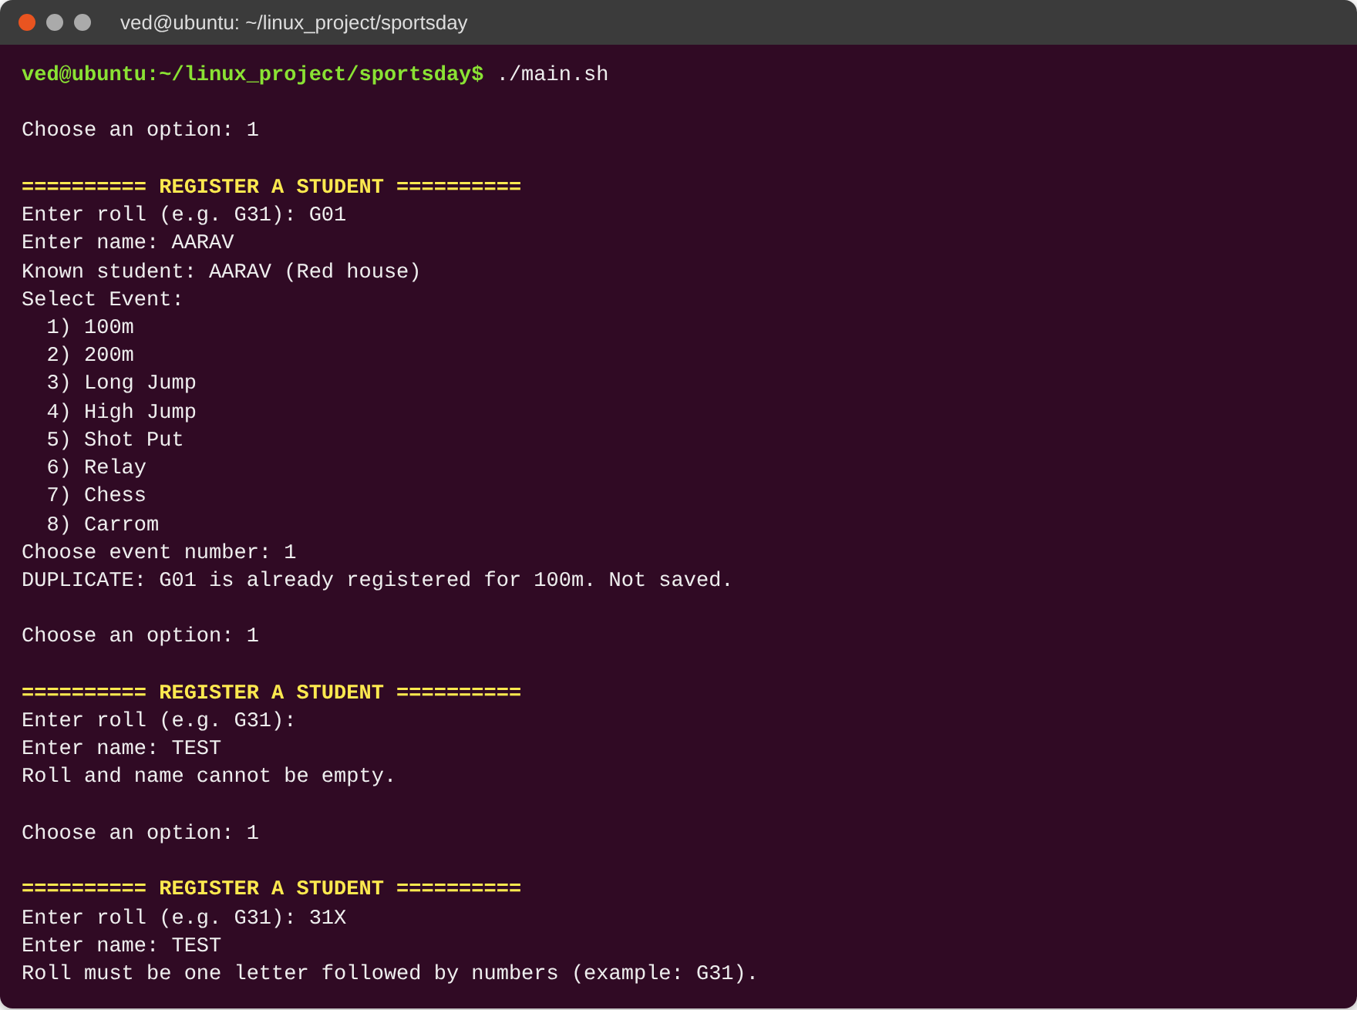

Feature 2: Count of Players in Each Event
This feature takes the event column, skips the header with tail -n +2, then uses sort and uniq -c to count the players in each event. A second sort -nr shows the biggest event first.
tail -n +2 "$DATA" | cut -d',' -f4 | sort | uniq -c | sort -nr

Screenshot: Feature 2 – Players in each event
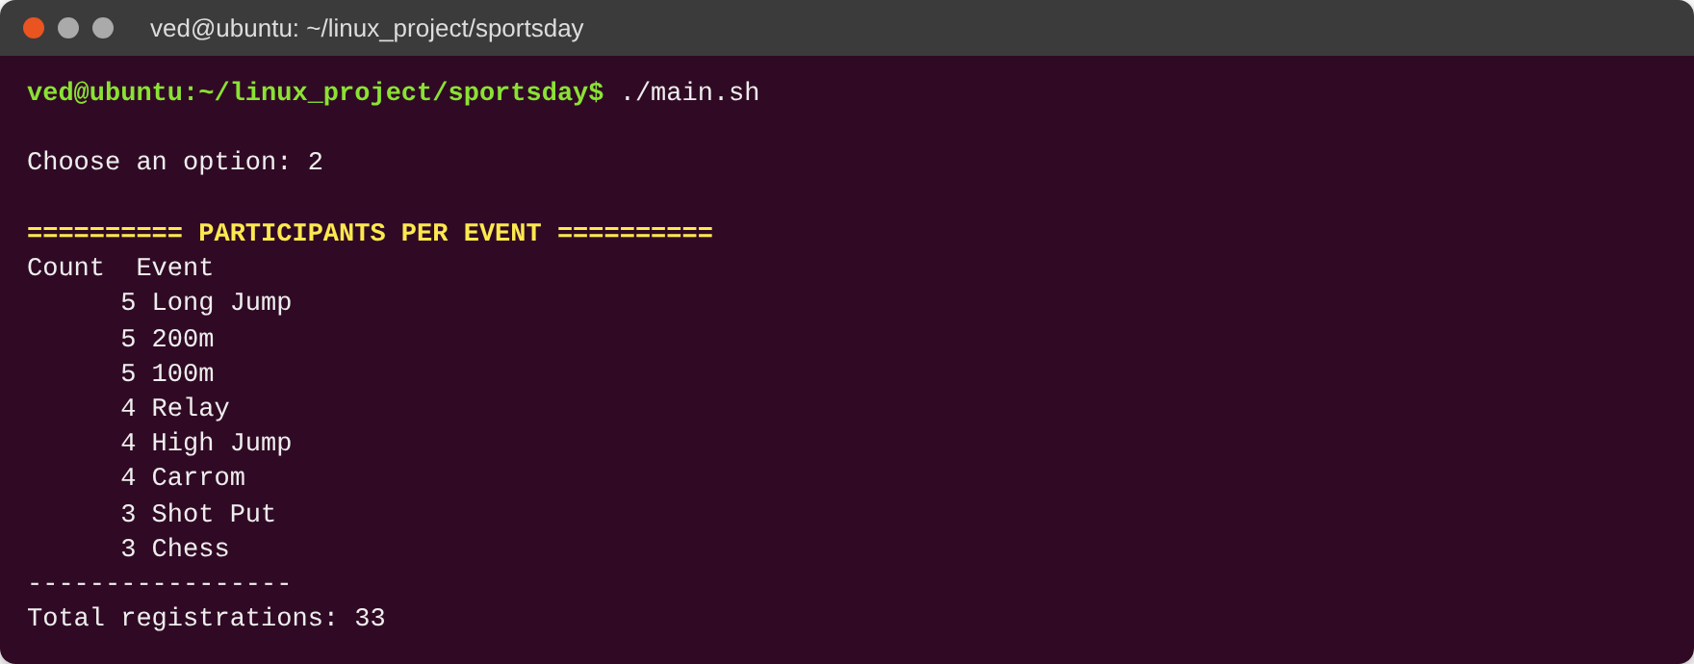

Feature 3: List of One House
The user picks a house. The script uses grep to select that house, sort to arrange by roll, and awk to print roll, name and event in columns. It also shows the total.
Screenshot: Feature 3 – Blue house list
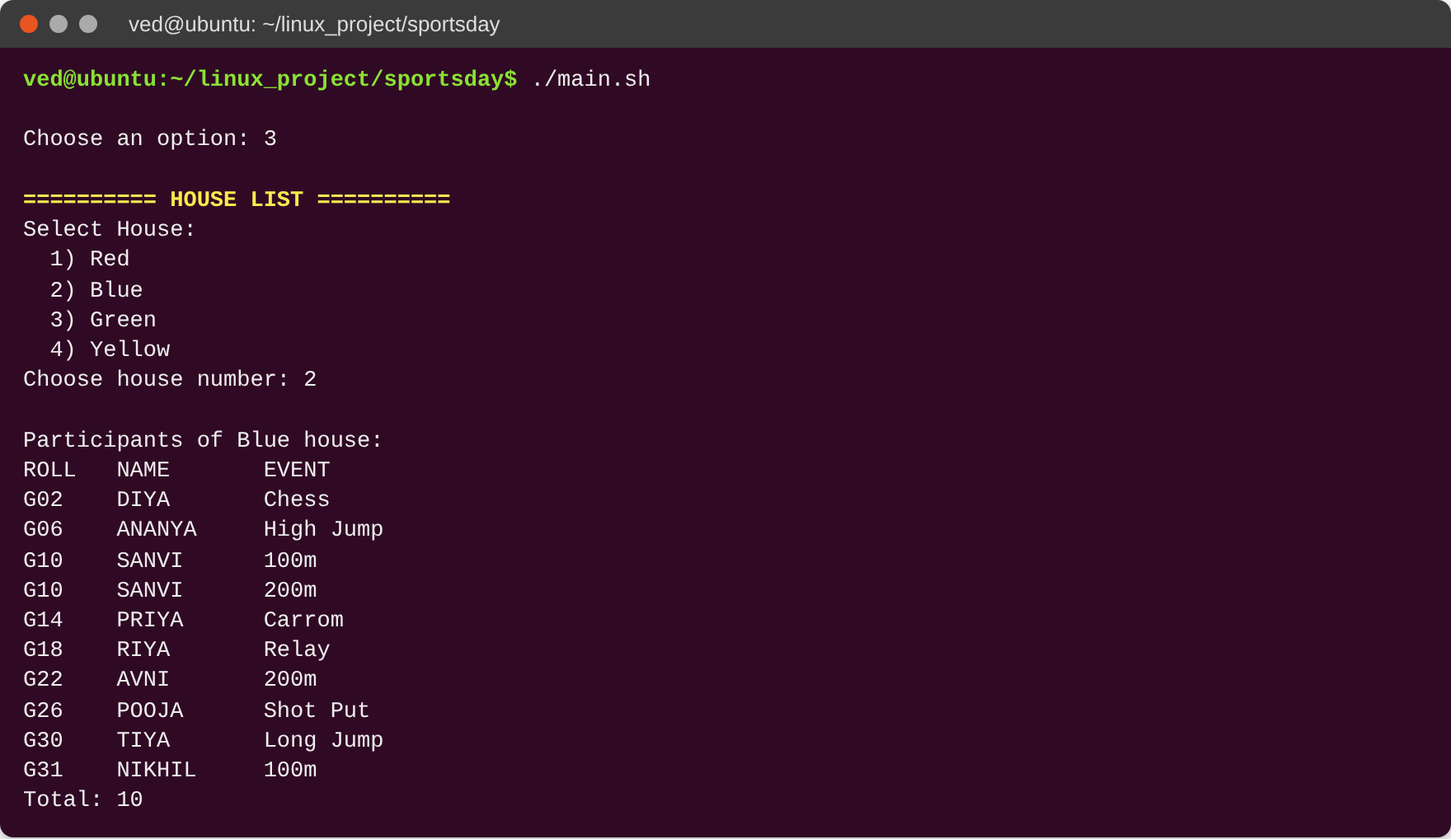

Feature 4: Certificates for Winners
The user picks an event. A for loop then runs for first, second and third place. For each place, the script asks for the winner’s roll and checks that the student is in that event. Then it creates a certificate text file with a here-document. The name, house, place, event and date are filled in by the script. Files are saved in reports/certificates/.
Screenshot: Feature 4 – Creating certificates for the 100m winners
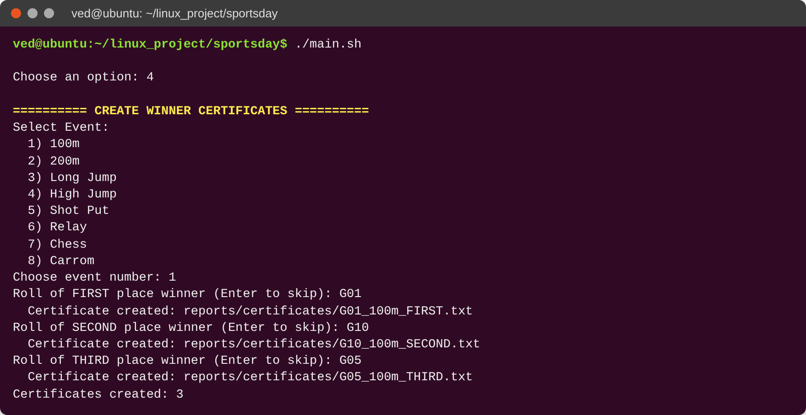
Screenshot: Feature 4 – A certificate file
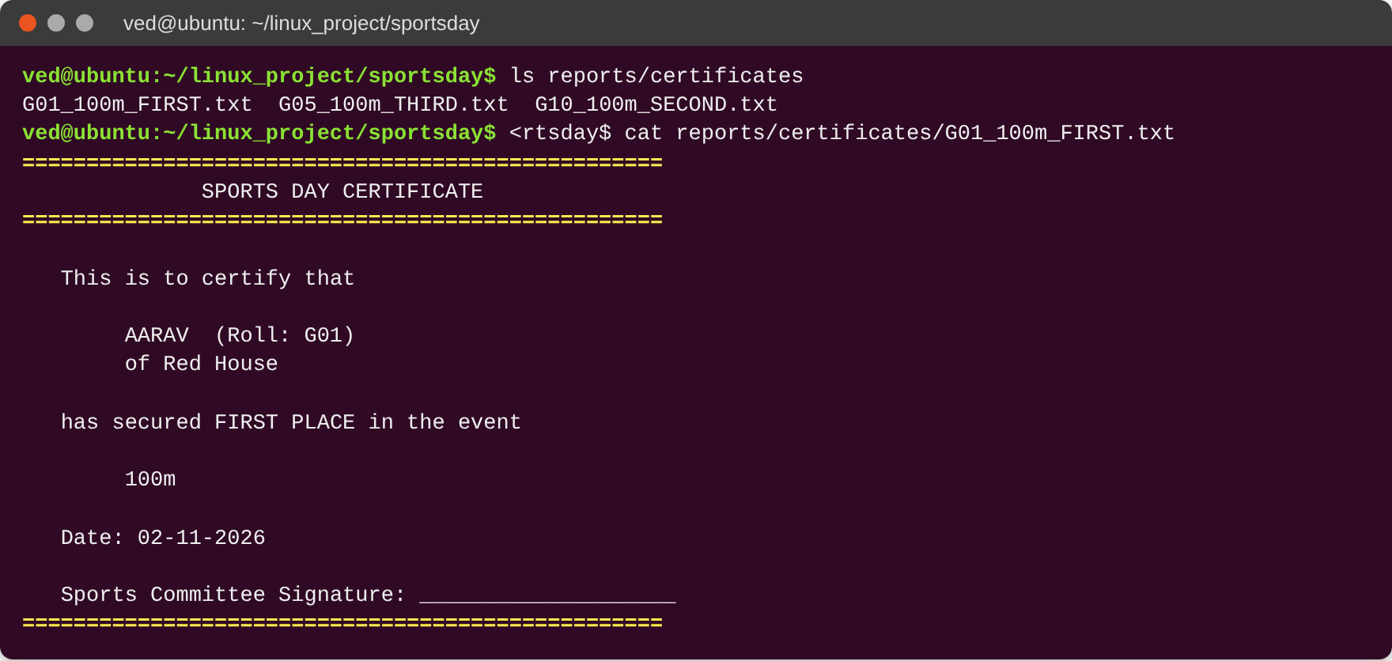

Feature 5: Remove a Registration
The user enters a roll. The script shows that student’s entries, then asks for the event and a y/n confirmation. Because sed -i changes the file directly, the script first makes a safety copy (participants.csv.bak). Then it deletes the row with sed -i. If the roll is not in the file, it prints “Not found”.
Screenshot: Feature 5 – Removing a registration
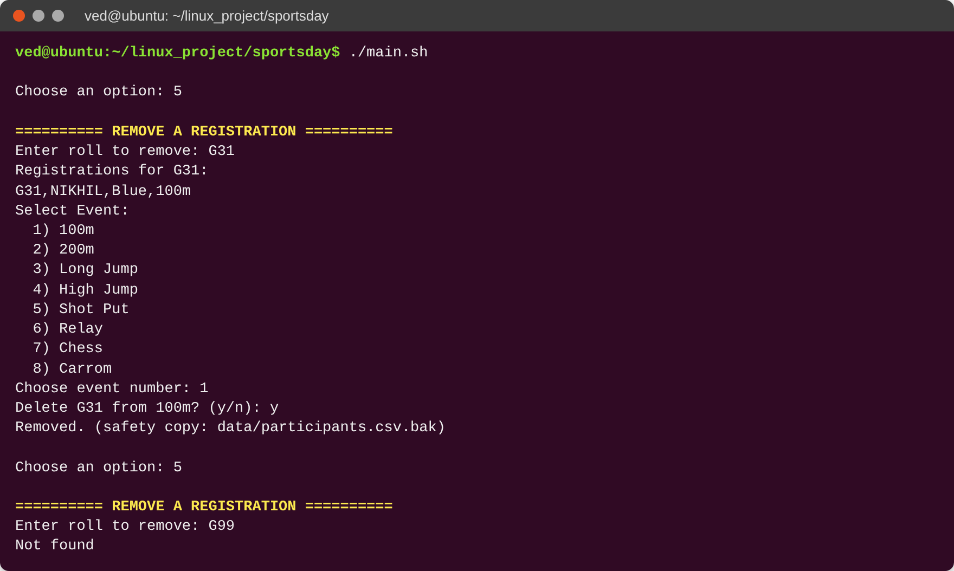

View Data and Backup
View Data shows all rows with line numbers (cat -n) and the total. Backup makes a compressed file of the data folder with tar -czf. The file name has the date and time. Backup can also be run from the command line with ./main.sh --backup.
Screenshot: View data
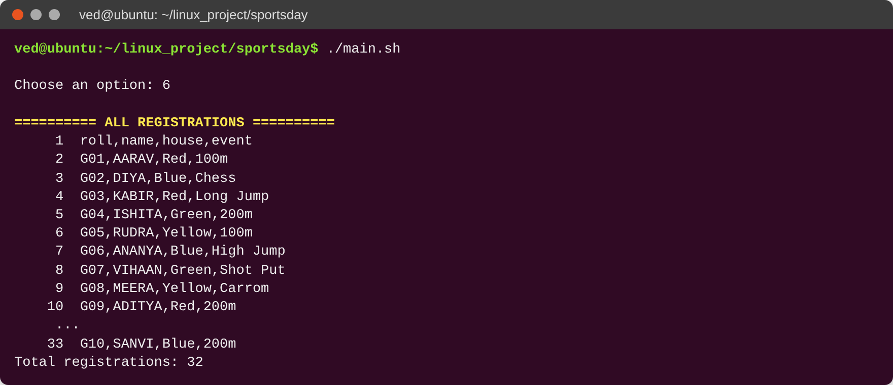
Screenshot: Backup from the menu
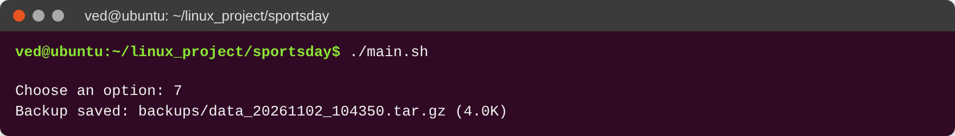
Screenshot: Backup file and what is inside it (tar -tzf)
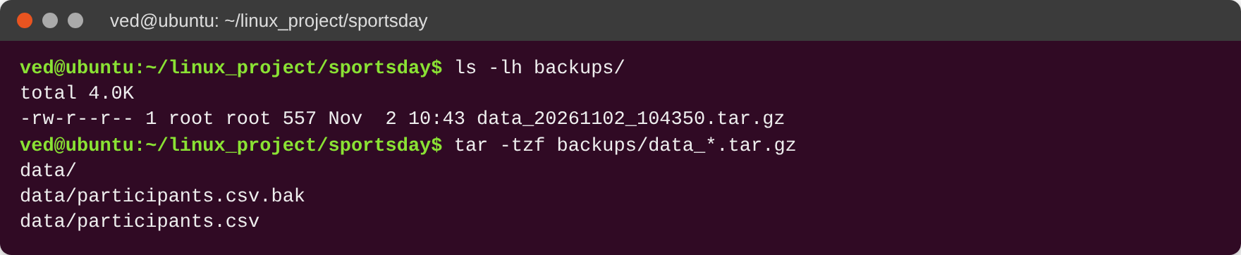

Activity Log and Input Checks
Every function writes a line with date and time to logs/activity.log using the log() function. Option 8 shows the last 15 lines. The log records registrations, blocked duplicates, certificates, removals, views, backups and cron runs.
Checks used in the script: empty input (-z), numbers only ([[ $n =~ ^[0-9]+$ ]]), roll format with a regular expression, no commas so the CSV does not break, data file must exist (check_data), and a confirmation plus .bak copy before sed -i.
Screenshot: Activity log
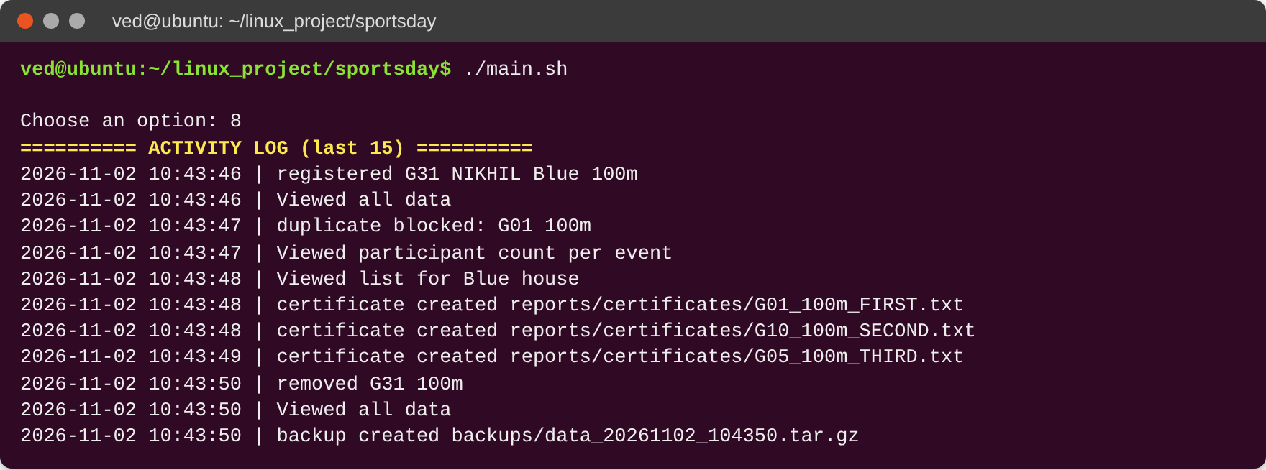
Screenshot: Command-line options (--help and --backup use $1)
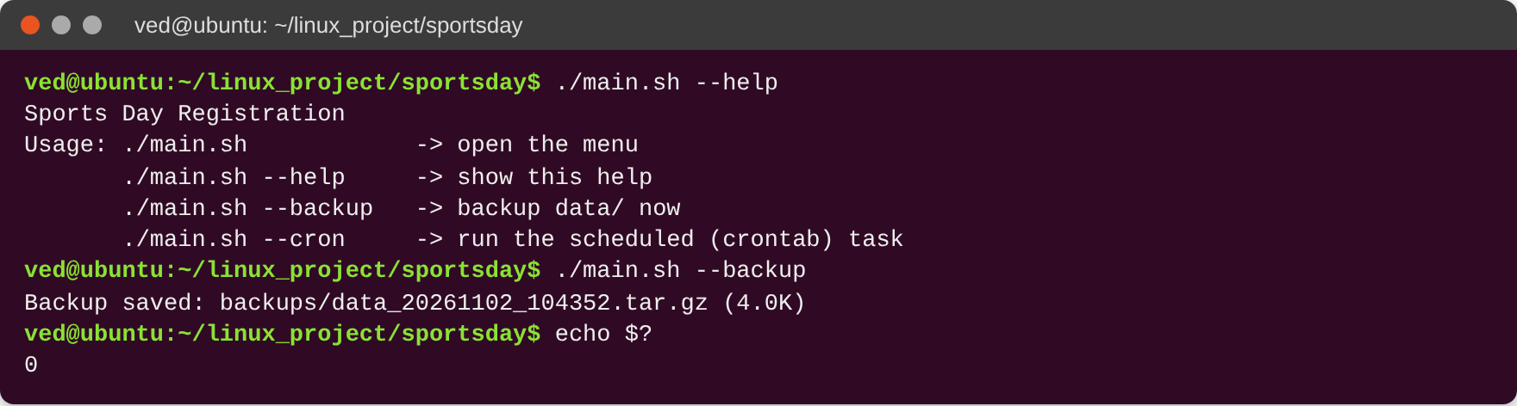
Screenshot: Debugging with bash -x
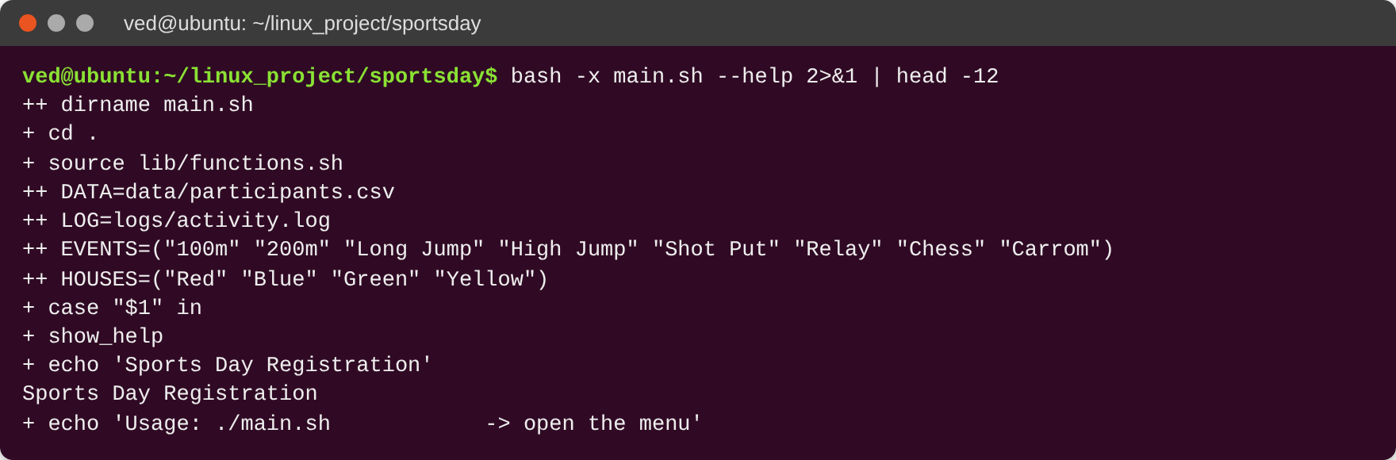

Cron Task: Daily Backup at 6 PM
The project backs up participants.csv every day at 6 PM with tar -czf. Cron runs ./main.sh --cron, which calls the cron_task() function.
Crontab line:
0 18 * * * /bin/bash $HOME/linux_project/sportsday/main.sh --cron >> $HOME/linux_project/sportsday/logs/cron.log 2>&1

The five time fields: 0 = minute 0, 18 = hour 18 (6 PM), * = every day of the month, * = every month, * = every day of the week.
Screenshot: Testing the cron task by hand (./main.sh --cron)
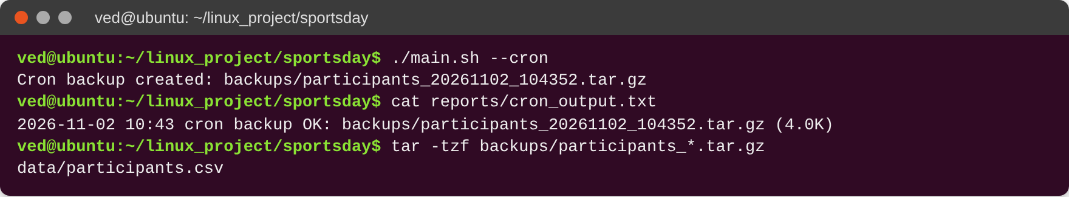
Screenshot: crontab -l and logs/cron.log
[Insert your own Ubuntu screenshot of crontab -l and logs/cron.log here, after adding the line with crontab -e]

What I Learned
In this project I practised Bash scripting with functions, while and for loops, if and case statements, and input checks. I learned to work with a CSV file using grep, cut, sort, uniq -c, awk and sed -i. I also learned to make files with a here-document, make tar.gz backups, keep an activity log, debug with bash -x and run a daily task with crontab.

Conclusion
Sports Day Registration shows how a shell script can become a useful menu-based program. The sports committee can register students without duplicates, see players per event and per house, print winner certificates, remove wrong entries and keep a daily backup. This project helped me understand Ubuntu Linux, Bash scripting and command-line tools better.

